Safeguarding Policy
The purpose of this policy statement is to protect children and young people from harm.
We believe that
Children and young people should never experience abuse of any kind. We have a responsibility to promote the welfare of all children and young people, to keep them safe and to practise in a way that protects them.
We recognise that:
• the welfare of children is paramount in all the work we do and in all the decisions we take all children, regardless of age, disability, gender reassignment, race, religion or belief, sex, or sexual orientation have an equal right to protection from all types of harm or abuse.
• some children are additionally vulnerable because of the impact of previous experiences, their level of dependency, communication needs or other issues.
• working in partnership with children, young people, their parents, carers and other agencies is essential in promoting young people’s welfare.
We will seek to keep children and young people safe by:
• valuing, listening to and respecting them.
• adopting child protection and safeguarding best practice through our policies, procedures and code of conduct for staff and volunteers.
• recruiting and selecting volunteers safely, ensuring all necessary checks are made.
• recording, storing and using information professionally and securely, in line with data protection legislation and guidance.
• using our safeguarding and child protection procedures to share concerns and relevant information with agencies who need to know, and involving children, young people, parents, families and carers appropriately.
• using our procedures to manage any allegations against staff and volunteers appropriately.
• creating and maintaining an anti-bullying environment and ensuring that we have a policy and procedure to help us deal effectively with any bullying that does arise.
• ensuring that we provide a safe physical environment for our children, young people, staff and volunteers, by applying health and safety measures in accordance with the law and regulatory guidance.
• building a safeguarding culture where staff and volunteers, children, young people and their families, treat each other with respect and are comfortable about sharing concerns.
• the definitions of abuse and harm can be found on the following pages 7 – 11.

Definitions of Abuse and Neglect from Working Together to Safeguard Children 2023
Safeguarding and promoting the welfare of children is defined for the purposes of this guidance as: protecting children from maltreatment; preventing impairment of children’s health or development; ensuring that children are growing up in circumstances consistent with the provision of safe and effective care; and taking action to enable all children to have the best outcomes.
Child protection is defined as: Part of safeguarding and promoting welfare. This refers to the activity that is undertaken to protect specific children who are suffering, or are likely to suffer, significant harm.
What is abuse and neglect?
A form of maltreatment of a child. Somebody may abuse or neglect a child by inflicting harm, or by failing to act to prevent harm. Children may be abused in a family or in an institutional or community setting by those known to them or, more rarely, by others (e.g. via the internet). They may be abused by an adult or adults, or another child or children.
Physical abuse-A form of abuse which may involve hitting, shaking, throwing, poisoning, burning or scalding, drowning, suffocating or otherwise causing physical harm to a child. Physical harm may also be caused when a parent or carer fabricates the symptoms of, or deliberately induces, illness in a child.
Emotional abuse-The persistent emotional maltreatment of a child such as to cause severe and persistent adverse effects on the child’s emotional development. It may involve conveying to a child that they are worthless or unloved, inadequate, or valued only insofar as they meet the needs of another person. It may include not giving the child opportunities to express their views, deliberately silencing them or ‘making fun’ of what they say or how they communicate. It may feature age or developmentally inappropriate expectations being imposed on children. These may include interactions that are beyond a child’s developmental capability, as well as overprotection and limitation of exploration and learning, or preventing the child participating in normal social interaction. It may involve seeing or hearing the ill-treatment of another. It may involve serious bullying (including cyber bullying), causing children frequently to feel frightened or in danger, or the exploitation or corruption of children. Some level of emotional abuse is involved in all types of maltreatment of a child, though it may occur alone.
Sexual abuse-Involves forcing or enticing a child or young person to take part in sexual activities, not necessarily involving a high level of violence, whether or not the child is aware of what is happening. The activities may involve physical contact, including assault by penetration (for example, rape or oral sex) or non-penetrative acts such as masturbation, kissing, rubbing and touching outside of clothing. They may also include non-contact activities, such as involving children in looking at, or in the production of, sexual images, watching sexual activities, encouraging children to behave in sexually inappropriate ways, or grooming a child in preparation for abuse Sexual abuse can take place online, and technology can be used to facilitate offline abuse. Sexual abuse is not solely perpetrated by adult males. Women can also commit acts of sexual abuse, as can other children.
Neglect-The persistent failure to meet a child’s basic physical and/or psychological needs, likely to result in the serious impairment of the child’s health or development. Neglect may occur during pregnancy as a result of maternal substance abuse.

Once a child is born, neglect may involve a parent or carer failing to:
• provide adequate food, clothing and shelter (including exclusion from home or abandonment);
• protect a child from physical and emotional harm or danger;
• ensure adequate supervision (including the use of inadequate care-givers); or
• ensure access to appropriate medical care or treatment.
It may also include neglect of, or unresponsiveness to, a child’s basic emotional needs.

Additional safeguarding concerns to be aware of are:
• Child Sexual Exploitation
• FGM – Female Genital Mutilation
• Forced Marriage
• Honour Abuse
• County Lines
• Child Criminal Exploitation
• Radicalisation
• Online Abuse

Additional Safeguarding Issues
Child Sexual Exploitation-CSE is a form of child sexual abuse. It occurs when an individual or group take advantage of an imbalance of power to coerce, manipulate or deceive a children or young person under the age of 18 into sexual activity (a) in exchange for something the victim needs or wants, and/or (b) for the financial advantage or increased status of the perpetrator or facilitator. The victim may have been sexually exploited even if the sexual activity appears consensual. CSE does not always involve physical contact; it can also occur through use of technology.
FGM – Female Genital Mutilation- (FGM) is a procedure where the female genitals are deliberately cut, injured or changed, but where there's no medical reason for this to be done. It's also known as "female circumcision" or "cutting". FGM is often performed by someone with no medical training who uses instruments such as a knife, scalpel, scissors, glass or razor blade. Children are rarely given anaesthetic or antiseptic treatment and are often forcibly restrained.
FGM is often motivated by beliefs about what is considered acceptable sexual behaviour. It aims to ensure premarital virginity and marital fidelity. FGM is in many communities believed to reduce a woman's libido and therefore believed to help her resist extramarital sexual acts. It is illegal to carry out FGM in the UK. It is also a criminal offence for UK nationals or permanent UK residents to perform FGM overseas or take their child abroad to have FGM carried out. The maximum penalty for FGM is 14 years’ imprisonment.
Forced Marriage-People have the right to choose who they marry, when they marry or if they marry at all. Forced marriage is when some face physical pressure to marry (for example, threats, physical violence or sexual violence) or emotional and psychological pressure (eg if they’re made to feel like they’re bringing shame on their family).
Forced marriage is illegal in England and Wales. This includes:
• taking someone overseas to force them to marry (whether or not the forced marriage takes place)
• marrying someone who lacks the mental capacity to consent to the marriage (whether they’re pressured to or not)
Honour Abuse-Honour based violence is a violent crime or incident which may have been committed to protect or defend the honour of the family or community.
It is often linked to family members or acquaintances who mistakenly believe someone has brought shame to their family or community by doing something that is not in keeping with the traditional beliefs of their culture. For example, honour based violence might be committed against people who:
• become involved with a boyfriend or girlfriend from a different culture or religion
• want to get out of an arranged marriage
• want to get out of a forced marriage
• wear clothes or take part in activities that might not be considered traditional within a particular culture
Women and girls are the most common victims of honour based violence however it can also affect men and boys. Crimes of ‘honour’ do not always include violence. Crimes committed in the name of ‘honour’ might include:
• domestic abuse
• threats of violence
• sexual or psychological abuse
• forced marriage
• being held against your will or taken somewhere the victim doesn’t want to go
• assault/killing
County Lines-A term used to describe gangs and organised criminal networks involved in exporting illegal drugs into one or more importing areas within the UK, using dedicated mobile phone lines or other form of ‘deal line’. They are likely to exploit children and vulnerable adults to move and store the drugs and money, and they will often use coercion, intimidation, violence (including sexual violence) and weapons.
Child Criminal Exploitation-A term to describe where an individual or group takes advantage of an imbalance of power to coerce, control, manipulate or deceive a child or young person under the age of 18 into any criminal activity:
(a) in exchange for something the victim needs or wants; and/or
(b) for the financial or other advantage or the perpetrator or facilitator; and/or
(c) through violence or the threat of violence.
The victim may have been criminally exploited even if the activity appears consensual. Child criminal exploitation does not always involve physical contact; it can also occur through the use of technology.
Radicalisation -When we talk about radicalisation it means someone is being encouraged to develop extreme views or beliefs in support of terrorist groups and activities. radicalisation and the potential path towards terrorism and extremism can occur through face to face or online interactions. It is sadly the case that it is becoming easier than ever to be groomed by terrorist recruiters on the internet and to find extremist materials.
Encouraging susceptible individuals to commit acts of terrorism on their own initiative is a deliberate tactic seen in emerging ideologies and seen in their propaganda. This is exacerbated by online environments which bring together and facilitate individuals sharing and validating thoughts and ideas.
Every case is different, and there is no checklist that can tell us if someone is being radicalised or becoming involved in terrorism. The importance of noticing the hallmarks of concern within these online communities, in friends or wider social spaces as well as work and educational settings has probably never been as important as it is now. There are some common signs that may mean someone is being radicalised.
• Expressing an obsessive or angry sense of injustice about a situation and blaming this on others.
• Expressing anger or extreme views towards a particular group such as a different race or religion.
• Suggesting that violent action is the only way to solve an issue, sharing extreme views or hatred on social media.

It’s often the case that professional curiosity and belief in your own ability to determine if something just doesn’t sit right is sometimes a good check point to flag up where something may be going wrong, especially in the early stages of radicalisation.

Online Abuse-any type of abuse that happens on the internet. It can happen across any device that's connected to the web, like computers, tablets, and mobile phones. It can happen anywhere online, including: social media, text messages and messaging apps, emails, online chats, online gaming and live-streaming sites. Children can be at risk of online abuse from people they know or from strangers. It might be part of other abuse which is taking place offline, like bullying or grooming. Or the abuse might only happen online.
Children may experience several types of abuse online: Cyberbullying, Emotional abuse-which can include emotional blackmail, Sexting-pressure or coercion to create sexual images, Sexual abuse, Sexual exploitation and Grooming-perpetrators may use online platforms to build a trusting relationship with the child to abuse them.
A child experiencing abuse online might:
-spend a lot more or a lot less time than usual online, texting, gaming or using social media
-seem distant, upset or angry after using the internet or texting
-be secretive about who they're talking to and what they're doing online or on their mobile phone
-have lots of new phone numbers, texts or email addresses on their mobile phone, laptop or tablet
Be mindful that some of the signs of online abuse are similar to other types of abuse.

Name and contact details of The Safeguarding Lead
Michaela Dartford
07788888921
MDartford@aol.com
Available 8am – 6pm Monday – Friday or anytime in an emergency

If the Safeguarding Lead is unavailable anyone with a safeguarding concern can contact The Children’s Advice and Duty Service (CADS).
-A staff member or volunteer can call (0344 800 8021)
-A member of the public or parent can call (0344 800 8020).

In the event of a disclosure what can you say to the child?
Listen carefully and do not stop or interrupt but do offer reassurance, be mindful of who else can hear the conversation. Never agree to ‘keep a secret’ but do reassure that sensitive information will not be shared with everyone. Do not ask leading questions. Avoid criticising the alleged perpetrator. Tell the child what you must do next – report etc.

What is the procedure at WILDlings in the event of a disclosure?
After a disclosure a record the child’s words must be made as soon as possible, do not alter in any way, then date it, record the time and sign. Inform group leader, parents, unless you feel doing so would put the child at further risk of harm or undermine a criminal investigation, or police without delay. There is a pencil and paper in the first aid kit. The forest school leader, Michaela Dartford (safeguarding Lead) must be informed as soon as posable. Any written safeguarding records will be kept securely during sessions and transferred as soon as possible to a locked cabinet within the forest school leader’s office.

Contacting the Children’s Advice and Duty Service (CADS)
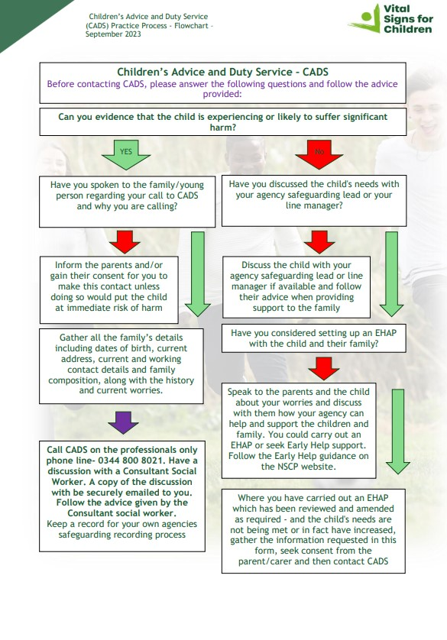
If there are any concerns about a child or young person in our forest school, this must be shared immediately with Norfolk’s Designated Safeguarding Leads, 01603 704040.
Where appropriate a safeguarding concern will be reported to LADO (Local Authority Designated Officer), PDC Duty Desk on 01603 307797 (Norfolk),
Looked After Children
A safeguarding concern involving a Looked After Child will also be reported to their relevant adviser / key contact.
To raise a safeguarding concern with Norfolk Children Services we will contact them on 0344 800 8020.
Home Educated Children
If there is a safeguarding concern about a home educated child we will contact the Home educators team 01603 307733.
A child attending a visiting school
The commissioning school retains the safeguarding responsibility for a child and any concerns (no matter how small) must be referred back to the commissioner without delay.
Children’s Advice and Duty (CADS) Service can be contacted on 0344 800 8021 (Norfolk).
Alternative Education Service
If the placement is under the remit of the Alternative Education Service (Section 19 team) – Schools or Virtual school for looked after and previously looked after children - Norfolk County Council the safeguarding section concerns will be addressed to the relevant adviser/key contact.
Prevention Referral
If we need to make a Prevent referral (the process where your concerns about a person who is susceptible to radicalisation) information will be either passed on via a national Prevent referral form or directly to the police for assessment.
See the end of this document for an up-to-date list of our Alternative Provision designated Safeguarding lead contacts.
For further support see Working together to safeguard children - GOV.UK (www.gov.uk)

Recording Form for Safeguarding Concerns
Staff, volunteers and regular visitors are required to complete this form and pass it to Michaela Dartford if they have a safeguarding concern about a child in our forest school.
Information Required | Enter Information Here
Full name of child
Date of birth
Class/tutor group/form group
Your name and position in the group
Nature of concern/disclosure
Please include where you were when the child made a disclosure, what you saw, who else was there, what did the child say or do and what you said.
[Ensure that if there is an injury this is recorded (size and shape) and a body map is completed]
[Make it clear if you have a raised a concern about a similar issue previously]
Time & date of incident:
Name and position of the person you are passing this information to?
Your Signature
Time and date form completed
Time form received by DSL
Action Taken by DSL
Referral made to police [yes/no, date and time]
Referral made to CADS [yes/no, date and time]
Referral Made to Other Agency [yes/no, date and time, name of organisation]
Feedback given to teacher
[yes/no, date and time]
Feedback given to child
[yes/no, date and time]
Feedback given to person who recorded disclosure
[yes/no, date and time]
Further Action Agreed
Full Name of DSL
Signature of DSL
Date of Signature

Body Map
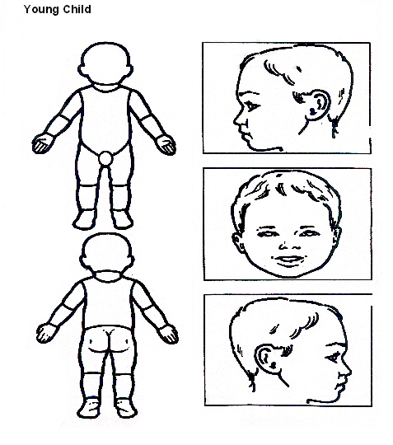Indicate clearly where the injury was seen and attach this to the referral form

Body Map
Older Child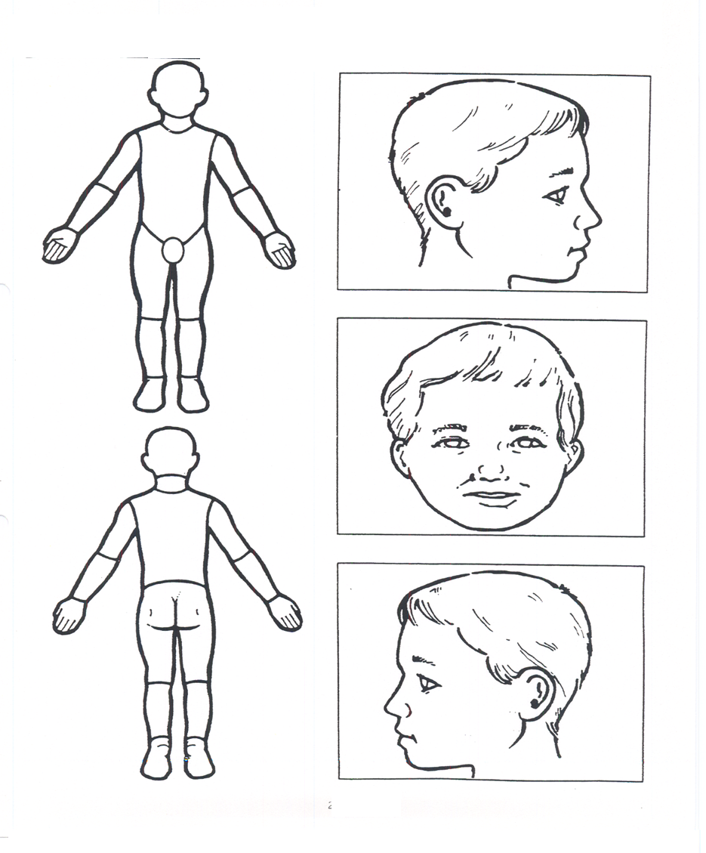
Indicate clearly where the injury was seen and attach this to the referral form.
Managing Allegations against people working or volunteering with children
Our aim is to provide a safe and supportive environment which secures the wellbeing and very best outcomes for the children who attend our setting. We do recognise that sometimes the behaviour of adults may lead to an allegation of abuse being made.
Allegations sometimes arise from a differing understanding of the same event, but when they occur, they are distressing and difficult for all concerned. We also recognise that many allegations are genuine and there are some adults who deliberately seek to harm or abuse children. We work to the thresholds for harm as set out in ‘Working Together to Safeguard Children’ (2023).
An allegation may relate to a person who works / volunteers with children who has:
• behaved in a way that has harmed a child, or may have harmed a child and/or;
• possibly committed a criminal offence against or related to a child and/or;
• behaved towards a child or children in a way that indicates he or she may pose a risk of harm to children; and/or
• behaved or may have behaved in a way that indicates they may not be suitable to work with children.
The 4th bullet point above recognises circumstances where a member of staff (including locum or supply staff) or volunteer is involved in an incident outside of setting/agency/work place which did not involve children but could have an impact on their suitability to work with children; this is known as transferrable risk.
At WILDlings we recognise our responsibility to report / refer allegations or behaviours of concern and / or harm to children by adults in positions of trust known to us, but who are not employed by our organisation to the LADO service directly at lado@norfolk.gov.uk
We will take all possible steps to safeguard our children and to ensure that the adults at WILDlings are safe to work with children. When concerns arise, we will always ensure that the safeguarding actions outlined in the local protocol and procedures NSCP Protocol 8.3 – Allegations Against Persons who Work/Volunteer with Children and The Management of Allegations Against People Working with Children Procedure are adhered to and will seek appropriate advice.
If an allegation is made or information is received about any adult who works/ volunteer in our setting which indicates that they may be unsuitable to work / volunteer with children, the member of staff receiving the information will inform Michaela Dartford immediately. This includes concerns relating to agency, supply and specialist staff, students and volunteers.
If a parent attending the group or a volunteer at the group makes an allegation about The Designated Officer, they can directly report their concern to the Local Authority Designated Officer (LADO). The parent or volunteer will need to complete a LADO referral form which can be downloaded from the Norfolk Safeguarding Children Partnership Website, and emailed to the LADO service directly at lado@norfolk.gov.uk

The Safeguarding lead, should within 1 working day, report the allegation to the LADO in accordance with this procedure, by completing a LADO referral form.

The referral form can be downloaded here, along with more information:
https://norfolklscp.org.uk/people-working-with-children/how-to-raise-a-concern

For further information on the role/remit of Norfolk LADO Service, please see NSCP Protocol 8.3 – Allegations Against Persons who Work/Volunteer with Children and The Management of Allegations Against People Working with Children Procedure

If you must report an allegation to any other professional body (e.g. Ofsted) also include the procedure for that within this section.

Making a Barring Referral to the Disclosure and Barring Service (DBS)
If an allegation has been made about a staff member or volunteer, then our organisation has a legal duty to make a barring referral if the following conditions are met:
Condition 1
• you withdraw permission for a person to engage in regulated activity with children and/or vulnerable adults. Examples: dismissed, re-deployed, retired, been made redundant or retired.
Condition 2
You think the person has carried out 1 of the following:
• engaged in relevant conduct in relation to children and/or adults. An action or inaction has harmed a child or vulnerable adult or put them at risk or harm or;
• satisfied the harm test
• received a caution for, or a conviction for, or been convicted for a relevant offence
More information on Barring Referrals can be found online
If we need guidance on making a Barring Referral, we will contact the East of England DBS Outreach Advisor for support.
A Barring Referral can be completed online via the DBS website
The person responsible for making a barring referral is Michaela Dartford. If the barring referral allegation is against the Michaela Dartford then referrals must be made by the concerned person.
There could be times when we might consider that we should still make a referral in the interests of safeguarding children even if the legal duty to refer has not been met. This could include acting on advice of the police or a safeguarding professional, or in situations where there may not be enough evidence to dismiss or remove a person from working with vulnerable groups. DBS are required by law to consider any and all information sent to them from any source. This includes information sent to them where the legal referral conditions are not met. If we do make a referral to DBS where the referral conditions are not met, we will do so in consideration of relevant employment and data protection laws.

Relevant Guidance and Legislation
-Working Together to Safeguard Children 2023
-What to do if You’re Worried a Child is Being Abused 2015
-Children Act 2004
-Children Act 1989
-The Online Safety Act 2023
-Data Protection Act 2018
-Norfolk Continuum of Needs Guidance 2023
Norfolk Guidance to Understanding Continuum of Needs | NSCP | PWWC (norfolklscp.org.uk)
-Norfolk Safeguarding Children Partnership Policies and Procedures
Polices & Procedures | Norfolk Safeguarding Children Partnership (norfolklscp.org.uk)
-Keeping Children Safe in Education (2025)

Working with parents and carers
This handbook is always kept in the waggon by the campfire. Parents and carers that attend for the stay and play sessions will be told where this is on arrival and able to view at any time. Schools that visit the forest school will be emailed a copy of this handbook.
Parents will be informed of our legal duty to assist other agencies with Safeguarding enquiries and what happens should we contact The Children’s Advice and Duty Services (CADS).
Parents will be made aware that we will need to share information with relevant authorities if we have concerns about the welfare of their child, we do not have to seek consent from them if there are serious concerns about harm or likely harm to their child.

